Data Science Tool Mastery Project
Yuva Intern – Task 4 | Data Analyst Internship
Name: ____________ Date: ____________ GitHub: ____________

1. Introduction and Objective
This project demonstrates hands-on proficiency with the industry-standard tools used by data analysts: Python (pandas, NumPy, Matplotlib, Seaborn), SQL (PostgreSQL), Power BI, Jupyter Notebook and Git/GitHub. One real-world dataset is taken through the complete workflow: raw data → cleaning → analysis → database → dashboard → portfolio.
Objectives:
- Master industry-standard tools relevant to data analytics.
- Demonstrate proficiency through practical exercises.
- Create portfolio pieces showcasing the skills.

2. Tools Selected
Tool | Purpose in this project
Python (pandas, NumPy) | Data loading, cleaning, feature creation
Matplotlib, Seaborn | Exploratory data analysis and charts
Jupyter Notebook | Running and documenting the analysis
SQL (PostgreSQL) | Storing the data and answering business questions
Power BI | Interactive dashboard
Git and GitHub | Version control and portfolio hosting

3. Dataset Overview
- Source: Air Quality Data in India (Kaggle), file station_day.csv
- Size: 108,035 rows × 16 columns, 110 monitoring stations
- Period: daily readings from 01-01-2015 to 01-07-2020
- Columns: StationId, Date, PM2.5, PM10, NO, NO2, NOx, NH3, CO, SO2, O3, Benzene, Toluene, Xylene, AQI, AQI_Bucket
- Problems found: many missing values (Xylene 78.8%, NH3 44.5%, PM10 39.5%, Toluene 35.8%), 7,158 rows with no pollutant data, 1,883 rows with AQI above the official maximum of 500, sensor caps at 1000 in PM2.5 and PM10, and uneven station coverage across years.

import pandas as pd, numpy as np
df = pd.read_csv('station_day.csv')
print(df.shape)
df.head()

Output:
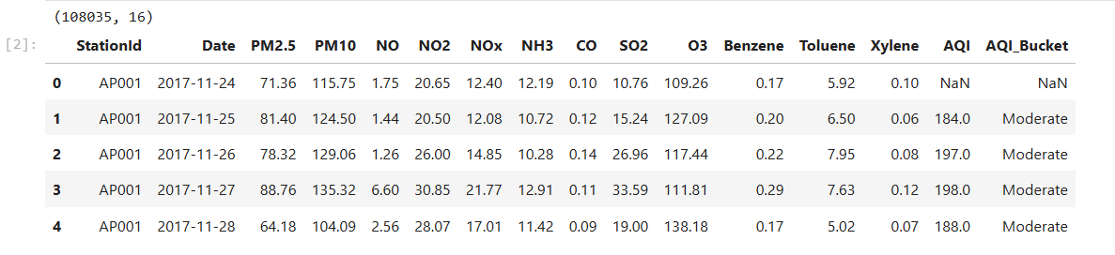
df.info()
(df.isna().mean()*100).round(1).sort_values(ascending=False)

Output:
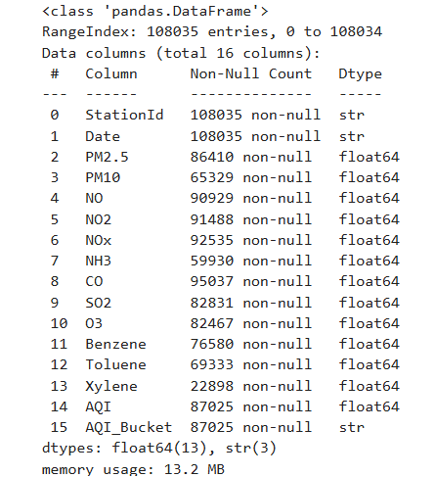
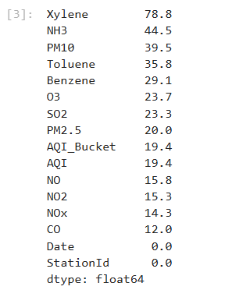

4. Step 1 – Python: Data Cleaning and EDA

4.1 Data cleaning (pandas, NumPy)
Cleaning decisions and the reason for each:
- Dates are in dd-mm-yyyy format, so the format is given explicitly while parsing. Year, Month, Season and State columns are created for analysis.
- Xylene is dropped because about 79% of its values are missing.
- Rows where every pollutant is missing carry no information, so they are removed.
- Remaining missing pollutant values are filled with the station-wise median, then the overall median.
- AQI is capped at 500 (the official maximum) and the AQI bucket is recomputed.
- Pollutant outliers are capped at the 99.5th percentile to reduce the effect of sensor errors.

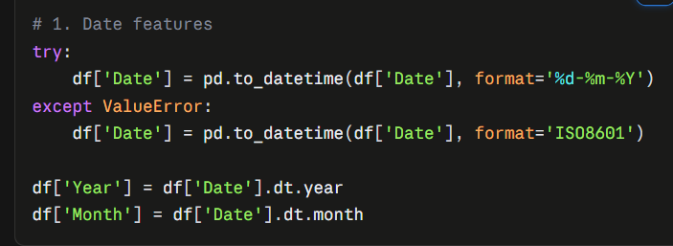
After run this code:
# 1. Date features
df['Date'] = pd.to_datetime(df['Date'], format='%d-%m-%Y')
df['Year'] = df['Date'].dt.year
df['Month'] = df['Date'].dt.month
def season(m):
return ('Winter' if m in (12,1,2) else 'Summer' if m in (3,4,5)
else 'Monsoon' if m in (6,7,8,9) else 'Post-Monsoon')
df['Season'] = df['Month'].map(season)
df['State'] = df['StationId'].str[:2] # AP001 -> AP
# 2. Drop Xylene and empty rows
df = df.drop(columns=['Xylene'])
pollutants = ['PM2.5','PM10','NO','NO2','NOx','NH3','CO','SO2','O3','Benzene','Toluene']
df = df.dropna(subset=pollutants, how='all')
# 3. Fill missing values (station median, then overall median)
df = df.sort_values(['StationId','Date'])
for c in pollutants:
df[c] = df[c].fillna(df.groupby('StationId')[c].transform('median'))
df[c] = df[c].fillna(df[c].median())
# 4. Fix AQI and rebuild bucket
df['AQI'] = df['AQI'].clip(upper=500)
def bucket(a):
if pd.isna(a): return np.nan
return ('Good' if a<=50 else 'Satisfactory' if a<=100 else 'Moderate' if a<=200
else 'Poor' if a<=300 else 'Very Poor' if a<=400 else 'Severe')
df['AQI_Bucket'] = df['AQI'].map(bucket)
df = df.dropna(subset=['AQI'])
# 5. Cap outliers
for c in pollutants:
df[c] = df[c].clip(upper=df[c].quantile(0.995))
df = df.reset_index(drop=True)
print('Clean shape:', df.shape)
df.to_csv('station_day_clean.csv', index=False)

Output:
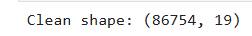

df.isna().sum()

Output:
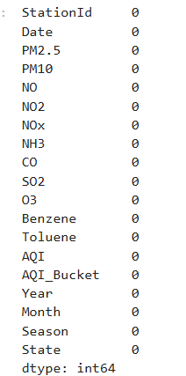

Metric | Before | After
Rows | 108,035 | 86,754
Columns | 16 | 19
Missing values | present in 14 columns | 0

4.2 Exploratory data analysis (Matplotlib, Seaborn)
import matplotlib.pyplot as plt
import seaborn as sns
sns.set_theme(style='whitegrid')
df = pd.read_csv('station_day_clean.csv', parse_dates=['Date'])
Chart 1 – Monthly average AQI
monthly = df.set_index('Date')['AQI'].resample('MS').mean()
plt.figure(figsize=(11,4))
monthly.plot()
plt.title('Monthly Average AQI'); plt.ylabel('AQI')
plt.show()

Output:
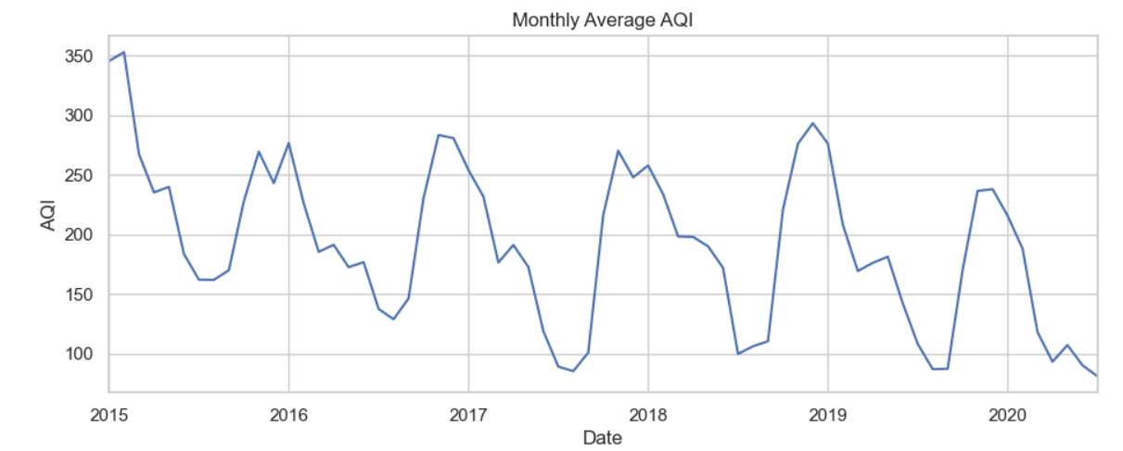

Insight: AQI rises every winter. Early months of 2015 have only about 21 stations (101 in 2019), so they do not represent all of India.
Chart 2 – AQI bucket distribution
order = ['Good','Satisfactory','Moderate','Poor','Very Poor','Severe']
plt.figure(figsize=(8,4))
sns.countplot(data=df, x='AQI_Bucket', order=order)
plt.title('Days by AQI Bucket')
plt.show()
df['AQI_Bucket'].value_counts(normalize=True).mul(100).round(1)

Output:
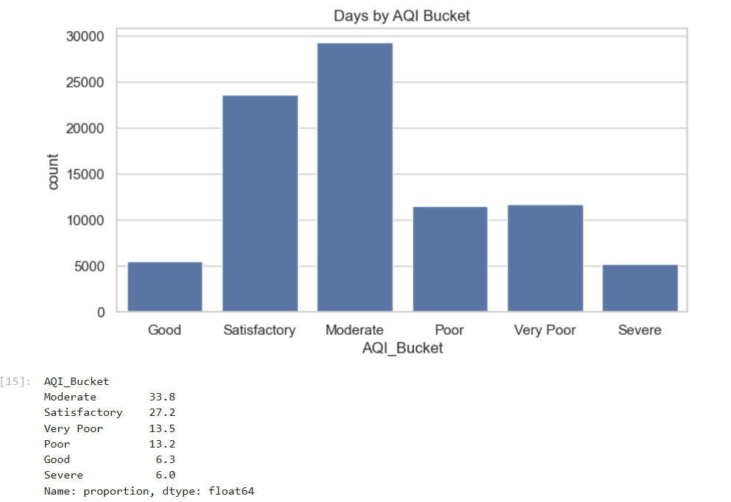

Insight: Moderate is the most common bucket (33.8%). About 32.7% of days are Poor, Very Poor or Severe, while only 6.3% are Good.
Chart 3 – Season-wise AQI
plt.figure(figsize=(7,4))
sns.barplot(data=df, x='Season', y='AQI',
order=['Winter','Summer','Monsoon','Post-Monsoon'], errorbar=None)
plt.title('Average AQI by Season')
plt.show()

Output:
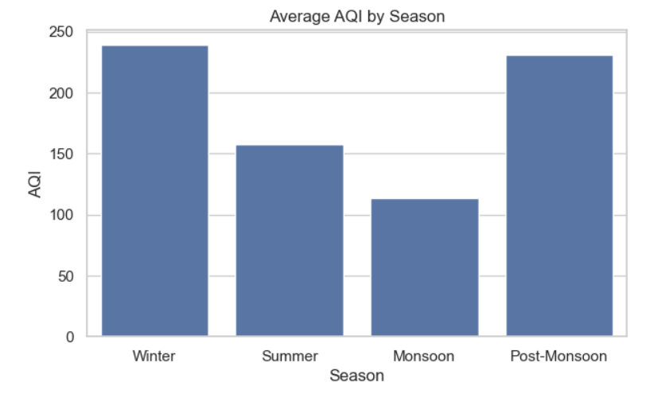
Insight: Winter (about 239) and Post-Monsoon (about 231) are the worst seasons. Monsoon (about 114) is the cleanest, because rain washes pollutants out of the air.
Chart 4 – Correlation heatmap
plt.figure(figsize=(9,7))
sns.heatmap(df[pollutants+['AQI']].corr(), annot=True, fmt='.2f', cmap='coolwarm')
plt.title('Correlation between pollutants and AQI')
plt.show()

Output:
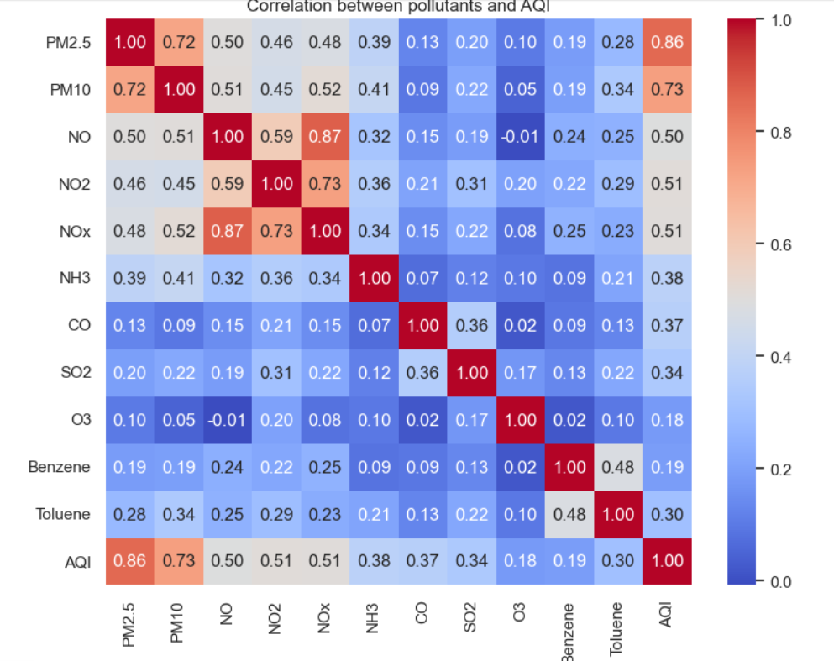
Insight: AQI is most strongly correlated with PM2.5 (0.86) and PM10 (0.73), so particulate matter is the main driver of poor air quality.
Chart 5 – Top 10 most polluted stations (only stations with at least 365 rows, for a fair comparison)
cnt = df.groupby('StationId').size()
valid = cnt[cnt >= 365].index
top = (df[df.StationId.isin(valid)]
.groupby('StationId')['AQI'].mean()
.sort_values(ascending=False).head(10))
plt.figure(figsize=(8,5))
sns.barplot(x=top.values, y=top.index, orient='h')
plt.xlabel('Average AQI'); plt.title('Top 10 Most Polluted Stations')
plt.show()

Output:
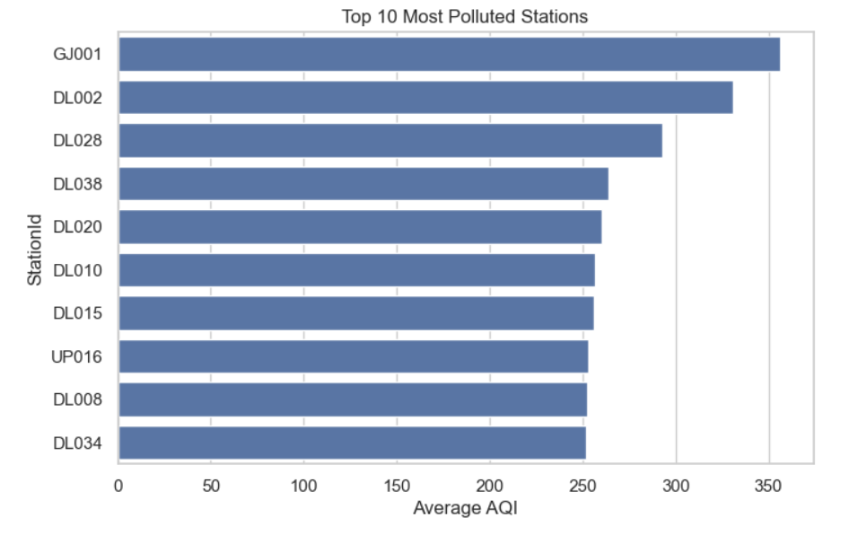

Insight: 8 of the top 10 stations are in Delhi (DL). GJ001 is the highest at about 356.
Chart 6 – Year-wise average AQI (2020 is excluded because data ends in July)
yr = df[df.Year < 2020].groupby('Year')['AQI'].mean()
plt.figure(figsize=(7,4))
yr.plot(kind='bar')
plt.ylabel('Average AQI'); plt.title('Average AQI by Year')
plt.xticks(rotation=0)
plt.show()

Output:
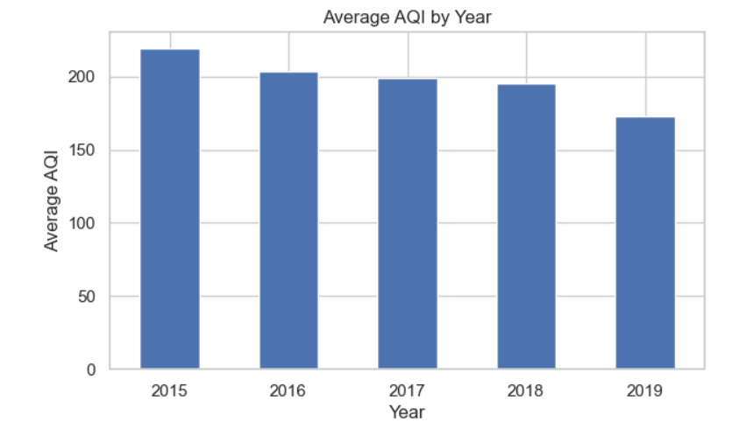

Insight: average AQI falls from about 219 (2015) to about 173 (2019). The number of stations also grew from 21 to 101 in the same period, so part of this change comes from coverage, not only from cleaner air.

Step 2

SQL (PostgreSQL)

5.1 Create the table and load the cleaned data
CREATE TABLE air_quality (
station_id VARCHAR(10),
obs_date DATE,
pm25 NUMERIC(8,2),
pm10 NUMERIC(8,2),
no_gas NUMERIC(8,2),
no2 NUMERIC(8,2),
nox NUMERIC(8,2),
nh3 NUMERIC(8,2),
co NUMERIC(8,2),
so2 NUMERIC(8,2),
o3 NUMERIC(8,2),
benzene NUMERIC(8,2),
toluene NUMERIC(8,2),
aqi NUMERIC(6,1),
aqi_bucket VARCHAR(15),
obs_year INT,
obs_month INT,
season VARCHAR(15),
state VARCHAR(5)
);

Output:
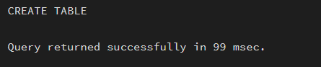

Load the CSV (run in psql, or use pgAdmin: right-click the table → Import/Export):
\copy air_quality FROM 'station_day_clean.csv' CSV HEADER
SELECT COUNT(*) FROM air_quality;
Output:
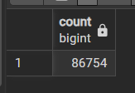

5.2 Business questions and queries
Q1. Overview of the data
SELECT COUNT(*) AS total_rows,
COUNT(DISTINCT station_id) AS stations,
MIN(obs_date) AS first_date,
MAX(obs_date) AS last_date
FROM air_quality;

Output:
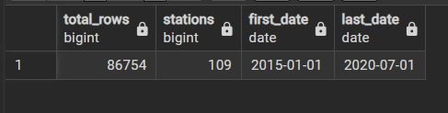
Q2. Average AQI by state
SELECT state, ROUND(AVG(aqi),1) AS avg_aqi, COUNT(*) AS readings
FROM air_quality
GROUP BY state
ORDER BY avg_aqi DESC;

Output:
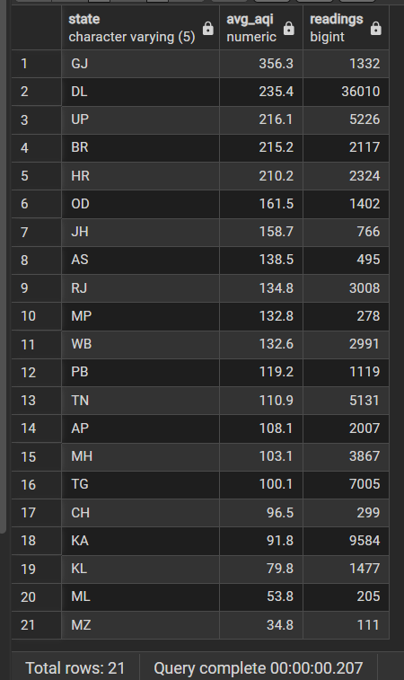

Insight: (write 1–2 lines in your own words)
Q3. Top 10 most polluted stations (at least 365 readings)
SELECT station_id, ROUND(AVG(aqi),1) AS avg_aqi, COUNT(*) AS readings
FROM air_quality
GROUP BY station_id
HAVING COUNT(*) >= 365
ORDER BY avg_aqi DESC
LIMIT 10;

Output:
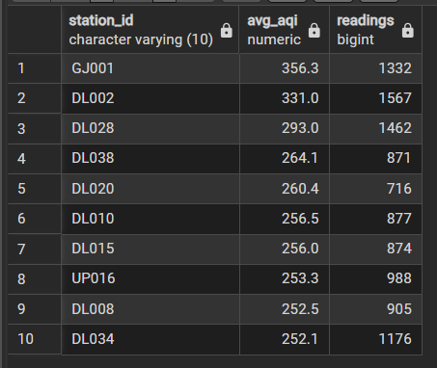

Insight: (write 1–2 lines in your own words)
Q4. Share of days in each AQI bucket (window function)
SELECT aqi_bucket,
COUNT(*) AS days,
ROUND(100.0 * COUNT(*) / SUM(COUNT(*)) OVER (), 1) AS pct
FROM air_quality
GROUP BY aqi_bucket
ORDER BY days DESC;

Output:
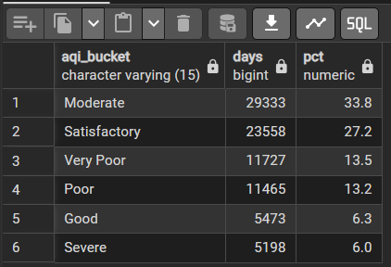
Insight: (write 1–2 lines in your own words)
Q5. Season-wise average AQI
SELECT season, ROUND(AVG(aqi),1) AS avg_aqi
FROM air_quality
GROUP BY season
ORDER BY avg_aqi DESC;

Output:
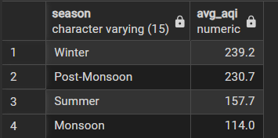
Insight: (write 1–2 lines in your own words)
Q6. Year-over-year change in AQI (CTE and LAG)
WITH yearly AS (
SELECT obs_year, ROUND(AVG(aqi),1) AS avg_aqi
FROM air_quality
WHERE obs_year < 2020
GROUP BY obs_year
)
SELECT obs_year,
avg_aqi,
LAG(avg_aqi) OVER (ORDER BY obs_year) AS previous_year,
avg_aqi - LAG(avg_aqi) OVER (ORDER BY obs_year) AS change
FROM yearly
ORDER BY obs_year;

Output:
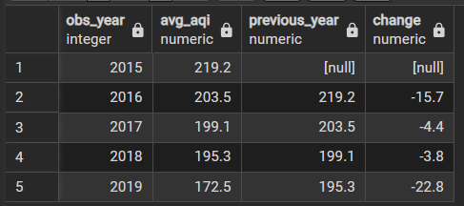
Insight: (write 1–2 lines in your own words; remember that station coverage grew every year)
Q7. Rank stations inside each state (CTE and RANK)
WITH station_avg AS (
SELECT state, station_id, ROUND(AVG(aqi),1) AS avg_aqi
FROM air_quality
GROUP BY state, station_id
HAVING COUNT(*) >= 365
)
SELECT state, station_id, avg_aqi,
RANK() OVER (PARTITION BY state ORDER BY avg_aqi DESC) AS rank_in_state
FROM station_avg
ORDER BY state, rank_in_state;

Output:
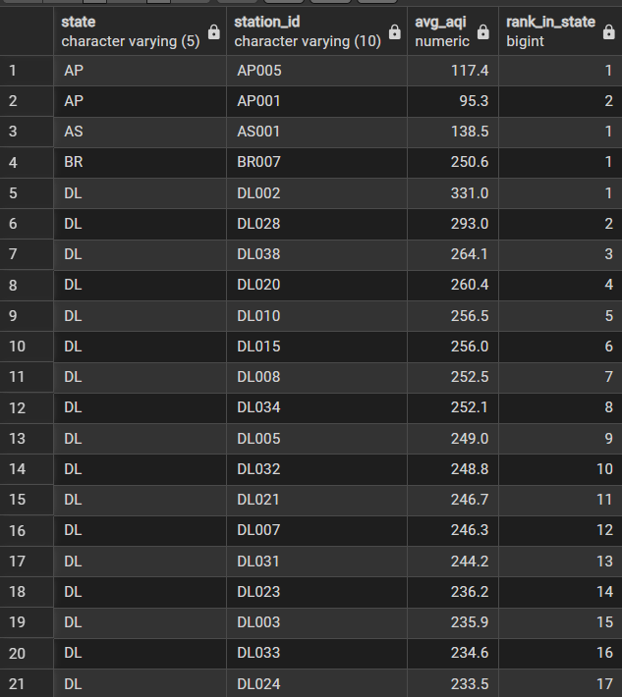
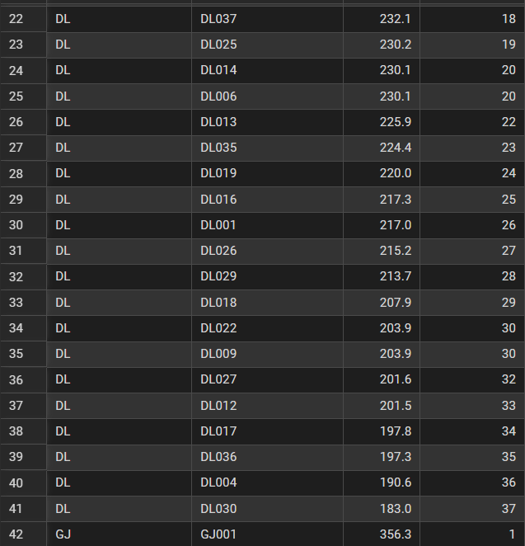
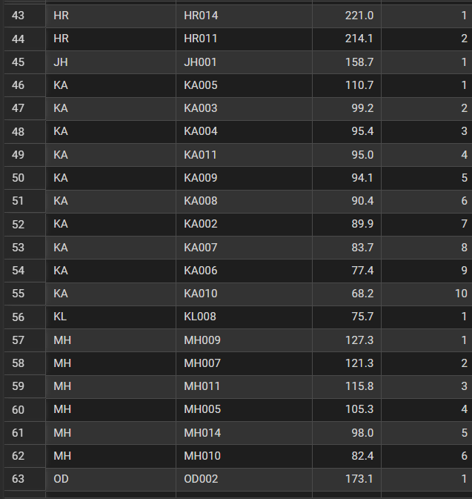
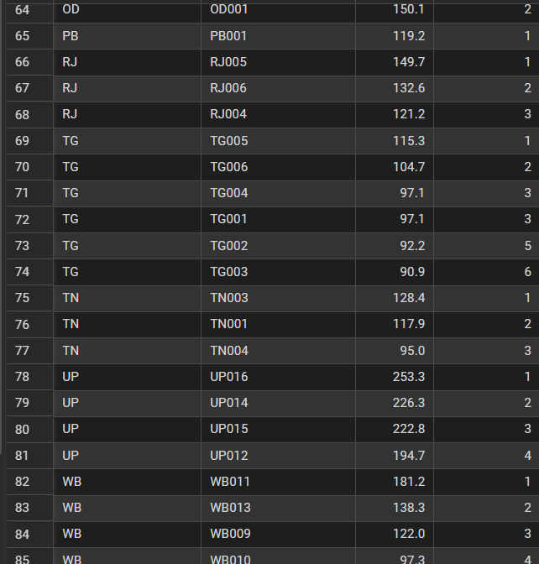
Insight: (write 1–2 lines in your own words)
Q8. Worst month of each year (CTE and RANK)
WITH monthly AS (
SELECT obs_year, obs_month, ROUND(AVG(aqi),1) AS avg_aqi
FROM air_quality
WHERE obs_year < 2020
GROUP BY obs_year, obs_month
),
ranked AS (
SELECT *, RANK() OVER (PARTITION BY obs_year ORDER BY avg_aqi DESC) AS rnk
FROM monthly
)
SELECT obs_year, obs_month, avg_aqi
FROM ranked
WHERE rnk = 1
ORDER BY obs_year;
Output:
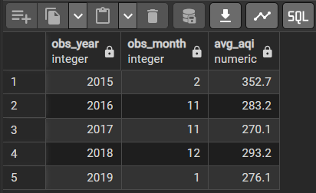
Insight: (write 1–2 lines in your own words)
Q9. 7-day moving average for one station (window frame)
SELECT obs_date, aqi,
ROUND(AVG(aqi) OVER (ORDER BY obs_date
ROWS BETWEEN 6 PRECEDING AND CURRENT ROW), 1) AS moving_avg_7d
FROM air_quality
WHERE station_id = 'DL007'
ORDER BY obs_date
LIMIT 30;

Output:
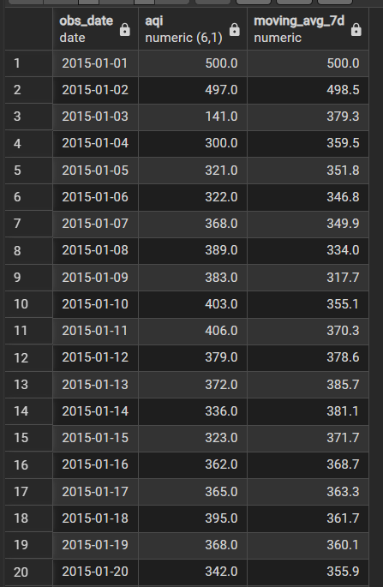
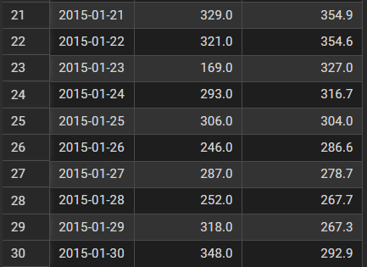

Insight: (write 1–2 lines in your own words)

6. Step 3 – Power BI Dashboard

6.1 Load the data
- Open Power BI Desktop → Get Data → Text/CSV → select station_day_clean.csv → Load. (Alternative: Get Data → PostgreSQL database → table air_quality; column names will then be station_id, aqi and so on.)
- Open Transform Data and check that Date is a Date type, AQI and pollutants are Decimal numbers, and Year and Month are Whole numbers.

Output:
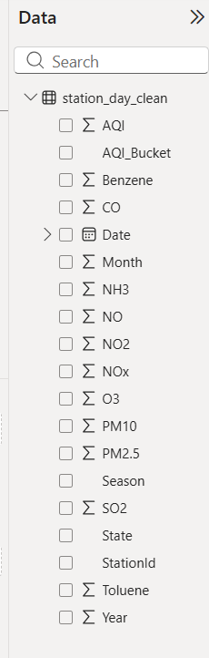

6.2 Create measures (Modeling → New measure)
Avg AQI = AVERAGE(station_day_clean[AQI])
Total Stations = DISTINCTCOUNT(station_day_clean[StationId])
Severe Days % =
DIVIDE(
CALCULATE(COUNTROWS(station_day_clean), station_day_clean[AQI_Bucket] = "Severe"),
COUNTROWS(station_day_clean)
)

Output:
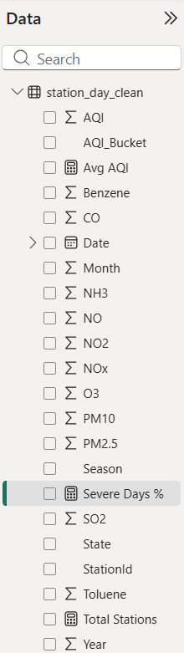

6.3 Build the dashboard
Visual | Fields
Card | Avg AQI
Card | Total Stations
Card | Severe Days %
Line chart | X-axis: Date (Year, Month); Y-axis: Avg AQI
Bar chart | Axis: State; Values: Avg AQI
Bar or donut chart | Axis: AQI_Bucket; Values: Count of StationId
Bar chart | Axis: Season; Values: Avg AQI
Slicers | Year, State, Season
Give the page a clear title, for example "India Air Quality Dashboard (2015–2020)", and use the same colours across visuals.
Output:
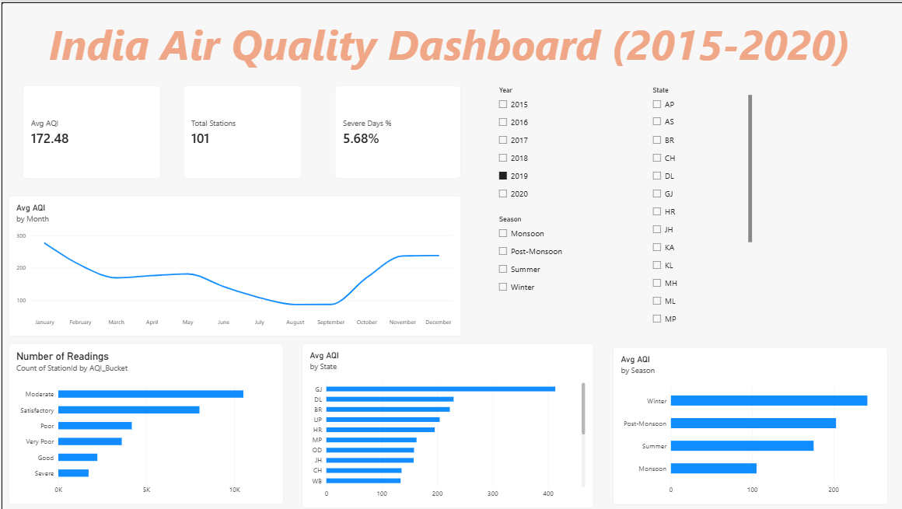
Output: full dashboard
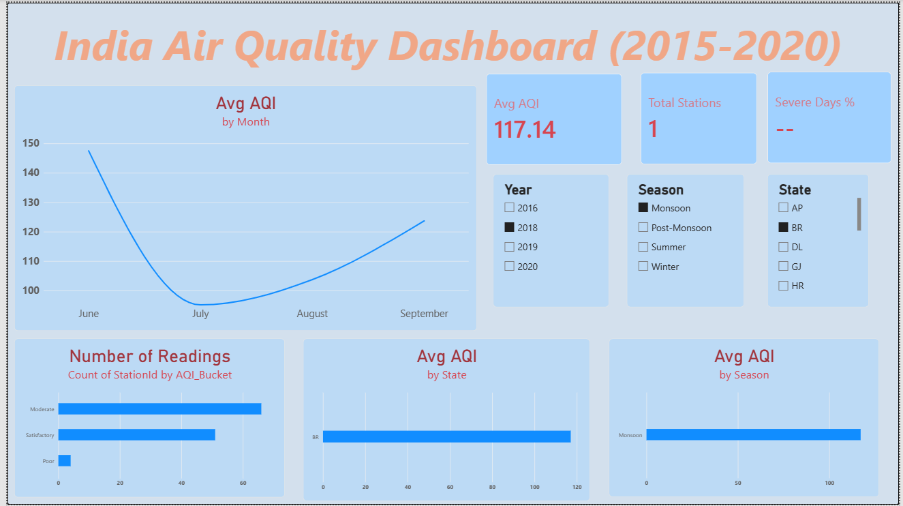
7. Step 4 – GitHub and Portfolio

7.1 Repository structure
yuva-task4-air-quality/
├── README.md
├── data/
│ └── station_day_clean.csv
├── notebooks/
│ ├── 01_data_cleaning.ipynb
│ └── 02_eda_visualizations.ipynb
├── sql/
│ └── queries.sql
├── dashboard/
│ └── dashboard_screenshot.png
└── report/
└── YuvaIntern_Task_4.docx

7.2 Push to GitHub
git init
git add .
git commit -m "Add Task 4: Python cleaning, EDA, SQL queries and dashboard"
git branch -M main
git remote add origin https://github.com/<your-username>/yuva-task4-air-quality.git
git push -u origin main
Screenshot 26: terminal showing a successful push
Screenshot 27: GitHub repository page with all folders visible

7.3 README contents
Title and one-line summary, dataset description, tools used, key findings (3–4 bullets), folder structure, how to run the notebooks, and a dashboard screenshot.

7.4 Add to the portfolio
Add a new project card to the portfolio website with: project title, 2-line description, tools used (Python, SQL, Power BI, GitHub), a link to the GitHub repository and the dashboard screenshot.
Screenshot 28: the new project card on the portfolio website

8. Challenges and Learnings
(Write 4–5 points in your own words. Things you may have faced: date parsing with the dd-mm-yyyy format, choosing how to fill missing values, unrealistic AQI values above 500, loading the CSV into PostgreSQL, understanding window functions, building measures in Power BI.)
- Challenge 1: ...
- Challenge 2: ...
- Challenge 3: ...
- What I learned: ...

9. Conclusion
Using one real-world dataset, this project covered the full analyst workflow with Python, SQL, Power BI and GitHub. Main findings: PM2.5 and PM10 are the biggest drivers of AQI, winter and post-monsoon are the most polluted seasons, and Delhi stations dominate the list of the most polluted locations. Station coverage grew a lot between 2015 and 2019, so year-wise trends must be read with care.

10. Links
- GitHub repository: ____________
- Dashboard (screenshot or published link): ____________
- Portfolio website: ____________

